**An Introduction to Materials: Nature and Properties (Part 1: Structure of Materials)**

**Prof. Ashish Garg**

**Department of Material Science and Engineering**

**Indian Institute of Technology, Kanpur**

**Lecture - 02**

**Bonding in Materials**

(Refer Slide Time: 00:21)



The structure of materials affects the properties, and the process can engineer structure. We looked at the structure has various length scales; they are macro, micro, nano, electronic and atomic, etc. So, the macrostructure is typically looked at by the naked eye. For micro, nano, or atomic structure, you go from optical to SEM to a TEM; this is the typical progression as you go from micro to nanostructure.

Then for the atomic or electronic structure, you have to do simulations typically. We discussed the structure of materials from the materials tetrahedron point of view because the structure is integrated intricately related to properties, processes, and applications. So, earlier, we classified materials in four categories, the first category is metals and alloys, second was ceramics and glasses, the third category was polymers and elastomers, and the fourth category was hybrids or composites.

(Refer Slide Time: 02:21)



As we know, metals are strong, ductile, and tough. However, they have poor corrosion resistance, they have high thermal conductivity, ceramics, on the other hand, are brittle, but they are very strong. However, they have low electrical and thermal conductivity, by and large, polymers, on the other hand, are soft, light, they can be stretched too long distances.

They are also tough, and they are also very corrosion resistant, but they are not very good for high-temperature applications. Composites, on the other hand, are manufactured by mixing two contrasting materials to leverage the advantage of both the different classes of materials. So far, we discussed one way of classifying the materials, and now we are going to discuss the material classification based on atomic bonding.

(Refer Slide Time: 03:57)

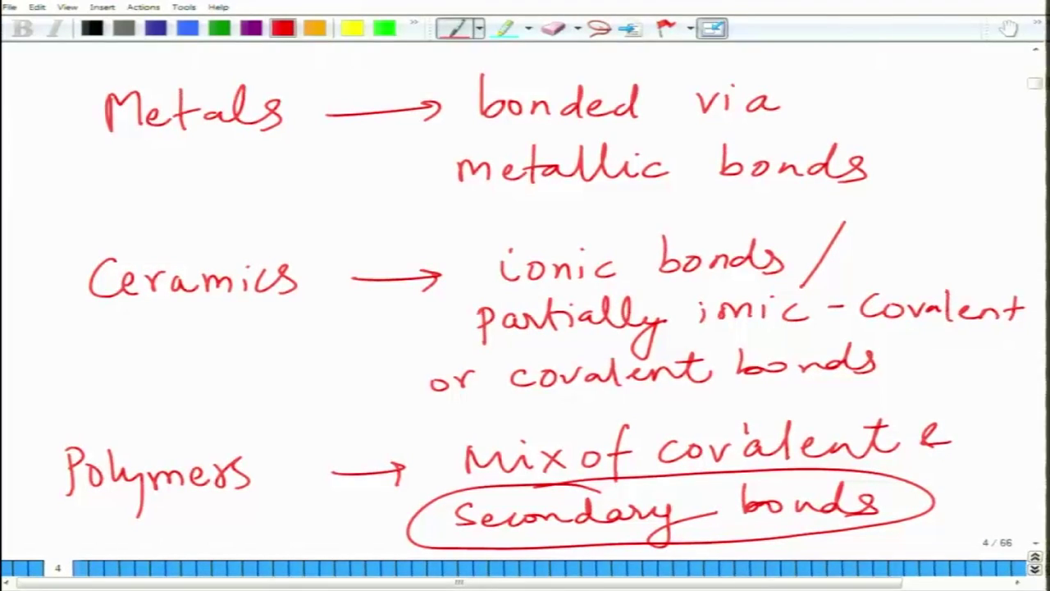

For example, metals and alloys are bonded via metallic bonds. Ionic bonds or partially covalent bonds bond ceramics and glasses. For example, sodium chloride would be highly ionic bonding; bonding in silicon carbide and zinc oxide will have partially ionic and covalent in bonding. Polymers, on the other hand, they have a mixture of covalent and secondary bonding.

Moreover, it is the nature of these bonds, which is very crucial in imparting the properties which these materials have. Metals have high electrical conductivity, high thermal conductivity, malleability, or ductility because of metallic bonding. Ceramics are strong, and they have low electrical, thermal conductivity, and they have a low coefficient of thermal expansion because ionic bonds or covalent bonds bond them.